Exploring the differences in predicted absorption capacity between UFF and DREIDING force fields.

Dara Daneshvar

# Abstract

My project explores the differences in using the UFF and DREIDING force fields in simulating the linearity of absorption isotherms at 273K. These two force fields rank the linearity of isotherms differently, and thus it is important to understand why. My investigation shows that there is indeed a difference, although, overall, the two force fields agree if a MOF is very linear, or not linear at all.

# Introduction

MOFs are currently difficult and expensive to synthesise; however, they are one of the main prospects for the future of carbon capture. The uncountable ways of combining metal ions and organic ligands allows chemists to access a limitless new variety of exotic materials, each with different absorption capabilities. Using computers, you can simulate the properties of MOFs to high accuracy before creating them and testing them in a laboratory. Because of this, computer science has become increasingly useful in finding candidates for the future of Carbon Capture – MOFs that are highly absorbent to CO2, but not N2. This, however, is not the only factor. One must also be able to release the CO2 they have absorbed easily. Because of this, the linearity of an MOFs isotherm is useful to know.

If an Isotherm is perfectly linear, one could remove the CO2 from the MOF just as easily as adding it. This is a desirable quality, and therefore, I have chosen it to be my project. By taking the r-squared value of the MOF’s isotherm compared to a straight line from the origin, you can analyse the linearity of this isotherm, and thus compare it to others. However, simulation requires you to choose a force field to simulate the behaviour of MOFs with. Since no simulation is perfect, different force fields will produce different results. The main two I am investigating are UFF and DREIDING. By compiling a list of the most linear isotherms when using UFF and then DREIDING, we can compare the two lists to look at how the two force fields differ.

# Methodology

In order to analyse the data gathered, I required the following libraries:

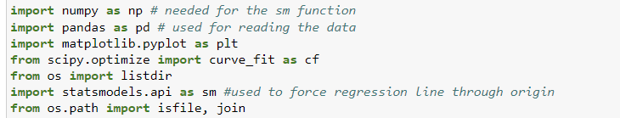

I downloaded all the data, and wrote code in Jupyter Notebook that creates a list of all files containing the data on Isotherms:

I then created code that compares the linearity of an isotherm. I did this by taking the R-squared value of the isotherm compared to a straight line through the origin:

Using this function, I was able to convert the list of files into a 2-dimensional list, with each element being a list containing the file, and its r-squared value. Note that I also filtered out files so that I was only creating a list of Isotherms at the same temperature, using the same charge types and forcefields.

Next, I sorted this 2-Dimensional list using a sort function:

When writing this code, I was planning on handling multiple types of 2D lists, and so I included an input x so that the function knows how to sort each element. In this case, the value that I would like to sort is the first value in the element, so I input x to be 0.

Now, I created 2 lists, one using the UFF force field, the other using DREIDING.



At this point, I had multiple options for comparing the similarity of these lists – which would give me insight on the effect of using DREIDING instead of UFF. I took a rolling window of size 50 across the lists and computed the rank correlation.

# Results and Evaluation

This function plots a graph of how similar different sections of the list are. I applied 3 different methods of comparing lists:

The top graph shows that there are no identical sections in either list. The bottom two show that despite this, the lists are not entirely dissimilar, as 1 means identical and -1 means opposite. What the bottom graphs show is that the higher ranks of MOFs are quite similar, as the values between 0 and 150 are positive by some margin. A similar conclusion can be drawn for the lower values of 550 and 650 for the same reasons. Therefore, while the lists are quite dissimilar, our analysis shows that both UFF and DREIDING agree to a moderate extent on how highly each MOF should be ranked depending on the linearity of their isotherms. For example, ASALIP is rank 0 using UFF, and rank 36 using DREIDING. MIL-88C-Open is rank 0 using DREIDING, and rank 2 using UFF. Noting that the lists both contain 726 elements, the proximity of these rankings is a demonstration of our conclusion.

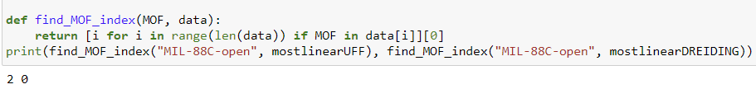

So, now that we have drawn our conclusion computationally, we can look at the chemistry to understand why UFF and DREIDING behave this way. Both force fields utilise both empirical parameters and theoretical parameters derived directly from quantum mechanics. UFF considers the bond lengths, bond stretching energy, the bond angles and the electrostatic interactions between atoms when simulating. DREIDING does the same but also explicitly considers Dihedral angles, thus changing the conformational space used during simulations.

At low pressures, Henry’s law tells us that the isotherm will look linear. At high pressures, the CO2 molecules are more tightly packed within the MOF pores and thus intermolecular interactions become more significant when it comes to the linearity. The main factor, however, is the inclusion of dihedral angles as mentioned before. By accounting for these, DREIDING provides a more accurate representation of the molecular flexibility of MOFs – including the movement of ligands and the accommodation of adsorbate molecules – when simulating the isotherms of MOFs, and thus is more accurate when looking for linearity.

# Conclusions

The two force fields produce different rankings of the linearity of the isotherms; however, this does not mean that they do not correlate to some extent. When looking at the Spearman’s Rho and Kendall’s Tau graphs, they seem to agree on when and where the lists become similar and dissimilar. Because of this, the previous conclusion that UFF and DREIDING agree to a moderate extent on the MOFs that exhibit high and low linearity in their isotherms but fail to agree on MOFs in the middle of their rankings. Overall, the use of either UFF or DREIDING can be important, and from the mechanisms of each one, I have argued that DREIDING is more accurate, due to its explicit consideration of Dihedral angles and more. UFF is generally perceived as superior when it comes to efficiency when simulating, while DREIDING tends to achieve more accurate results on average at the cost of more computation.